A 3 bed Bungalow located in Sandbanks priced at £
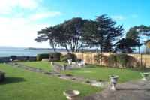 | A SPACIOUS DETACHED BUNGALOW RESIDENCE IN NEED OF MODERNISATION AND DECORATION OR ALTERNATIVELY, SUBJECT TO THE NECESSARY PLANNING PERMISSIONS, SUITABLE FOR REDEVELOPMENT. HAVING A FRONTAGE TO ALINGTON ROAD AND A REAR BOUNDARY TO SHORE ROAD. COMMANDING STUNNING PANORAMIC VIEWS OVER POOLE HARBOUR, SANDBANKS PENINSULA, BROWNSEA ISLAND AND THE PURBECK HILLS BEYOND.  STATUS: Available Now
Added/Updated: Tue Feb 11 12:24:37 2003 | Desirable Location Harbour Views

